##### Question/Answer Booklet

Name:

PHYSICAL EDUCATION STUDIES

Yr 11 ATAR 2021

**Semester 1: Class Test 1**

**Time allowed for this paper**

Working time for paper: 45 minutes

**Material required/recommended for this paper**

*To be provided by the supervisor*

This Question/Answer Booklet

|  |  |  |  |
| --- | --- | --- | --- |
| **Contents:**  Motor Learning and  Coaching | 18 Questions | **Total marks** | **/50** |

**Multiple Choice (10 marks)**

1. Throwing a dart, can be classified as a:

(a) Discrete, Closed motor skill.

(b) Continuous, Open motor skill.

(c) Serial, Closed motor skill.

(d) Gross, Open motor skill.

1. Augmented feedback in which a coach provides information regarding the outcome or success of the movement to their athlete, is known as:
2. specific feedback.
3. knowledge of results.
4. knowledge of performance.
5. knowledge of feedback.
6. In an offensive play of NFL gridiron, the quarterback receives the ‘snap’ pass from the centre, then looks to throw the ball downfield to an eligible receiver who is covered by a defending player, the quarterback then decides to run with the ball himself. According to the information-processing model, what stage of the model did the quarterback reach?
7. Identification of stimuli/input.
8. Response identification/decision-making.
9. Response/output.
10. Feedback.
11. A ten-pin bowler who watches the ball spin and travel path down the lane before then hearing the ball strike into the pins is receiving:

1. extrinsic feedback.
2. augmented feedback.
3. intrinsic feedback.
4. knowledge of performance.

5. During an Inter-School basketball game, a coach shouts out to her players ‘zone defence’, as the ball is turned over from a rebound. This is an example of:

(a) Terminal feedback.

(b) Concurrent feedback.

(c) Constructive feedback.

(d) Intrinsic feedback.

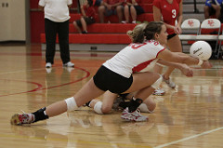6. In receiving a serve over the net, Phillipa decides to dig and moves accordingly. With reference to the Information Processing Model, this action is known as:

(a) Input.

(b) Output.

(c) Stimulus.

(d) Decision making.

7. Which of the following skills can be classified as the most discrete skill?

(a) 110m hurdles.

(b) Swimming 100m.

(c) Basketball free throw.

(d) Basketball lay-up

8. Knowledge of results is an example of:

(a) Inherent feedback.

(b) Concurrent feedback.

(c) Extrinsic feedback.

(d) Intrinsic feedback.

9. The day after a failed attempt at the Red Bull Cliff Diving, an athlete is told by her coach that she needed to get into her tuck earlier to allow for full extension prior to hitting the water. This feedback is

(a) external augmented, knowledge of performance, terminal.

(b) external augmented, knowledge of performance, concurrent.

(c) external intrinsic, knowledge of performance, terminal.

(d) external augmented, knowledge of result, concurrent.

10. During the second phase of learning, athletes should be encouraged to:

(a) Use their own feedback to detect and correct errors.

(b) Keep the learning environment exactly the same.

(c) Increase their reliance on augmented feedback to perfect the skill.

(d) Develop an understanding of how to perform the skill.

**Short Answer (30 marks)**

**Question 11 (4 marks)**

Four-time AFL premiership player Luke Hodge is nearing the end of his playing career. He mentioned in a recent interview that when he retires, he is looking forward to coaching his own children’s junior football team. Other than age, explain **two** individual differences that Luke will need to consider when coaching his children’s team and explain how he would have to alter training to cater for these differences.

**Question 12 (8 marks)**

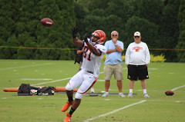

Using your understanding of the information-processing model, explain how to successfully execute the catch.

**Question 13**

Place the following activities (A, B, C, D) on the continuum below. **(2 marks)**

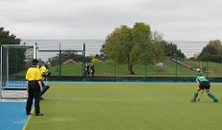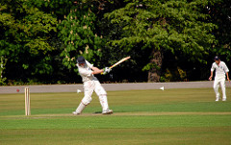

1. Cricket stroke **B**. Penalty stroke (green shirt)

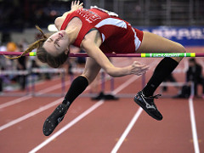

**C**. High jump **D**. Surfing

**OPEN CLOSED**

**Question 16 (2 marks)**

Athletes require multiple types of feedback to improve their performance. Explain the difference between internal and external feedback when performing a skill.

**Question 17 (6 marks)**

To maximise performance, a performer needs to be able to interpret and understand internal and external cues. Briefly explain the 3 main types of cues used and provide an example of each.

______________________________________________________________________________________________

______________________________________________________________________________________________

______________________________________________________________________________________________

______________________________________________________________________________________________

______________________________________________________________________________________________

______________________________________________________________________________________________

______________________________________________________________________________________________

**QUESTION 7 2 marks**

Consider the return of a badminton serve. Classify this skill by answering the questions below.

1. Is this a fine or gross motor skill? ____________________________________

Justify your classification.

______________________________________________________________________________________________

______________________________________________________________________________________________

______________________________________________________________________________________________

1. Is this a closed or open motor skill? ____________________________________ **2 marks**

Justify your classification.

______________________________________________________________________________________________

______________________________________________________________________________________________

______________________________________________________________________________________________

1. Is this a discrete, serial or continuous motor skill? _________________________ **2 marks**

Justify your classification.

______________________________________________________________________________________________

______________________________________________________________________________________________

______________________________________________________________________________________________

**QUESTION 8**

As a performer moves from the early stage of learning through to the final stage of learning, the type of feedback they use changes. Describe how feedback should differ at these two stages.

|  |  |
| --- | --- |
| **Cognitive Stage of learning** | **Autonomous stage of learning** |
|  |  |

**Extended Answer (10 marks)**

**Question 18 (10 marks)**

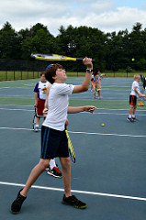

Joe has never played tennis and is practising his serve.

State Fitts and Posner’s three phases of learning, clearly identifying Joe’s current phase, and describe **two (2)** characteristics you would expect to see in his performance during this phase. As Joe’s coach, identify **two (2)** types of cues you can use with a relevant example to assist Joe in moving to the next phase of learning.

__________________________________________________________ ___________________________________________________________________________________________________________________________________________________________________________________________________________________________________________________________________________________________